FOREIGN KEY and ON UPDATE CASCADE

CHECK

DEFAULT



NOT NULL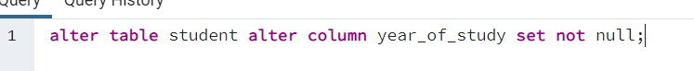

ON DELETE CASCDE

UNIQUE

PRIMARY KEY



ON DELETE SET NULL

